**Enhancing Patient Care Systems in Healthcare: Integrating Robotics and Voice-Generated Technology**

Himanshi and Vaishali

**Abstract**

The healthcare landscape is continually evolving, demanding novel approaches to patient care delivery. This research investigates the transformative potential of integrating cutting-edge technologies, specifically robotics and voice-generated devices, to revolutionize patient care systems. This paper offers an in-depth exploration into the challenges inherent in traditional healthcare models, emphasizing the critical need for innovative solutions to optimize care delivery. Understanding the intricacies of patient care systems, the paper elaborates on the complexities involved in providing comprehensive, personalized care within conventional healthcare frameworks. By leveraging robotics, the potential for precise, minimally invasive procedures, remote patient monitoring, and enhanced caregiver productivity is magnified, fostering a new era of patient-centered care. Simultaneously, the paper explores the burgeoning realm of voice-generated technology within healthcare. By harnessing the capabilities of AI-driven voice assistants and sophisticated voice recognition systems, healthcare interaction and data management undergo a paradigm shift. The integration of voice-generated devices optimizes patient engagement, streamlines information processing, and elevates overall healthcare efficiency, paving the way for seamless and intuitive patient care experiences.

**Introduction**

Patient care systems in healthcare represent the foundational framework that supports the delivery of medical services, aiming to ensure efficient, effective, and compassionate care for individuals seeking health-related interventions. The current landscape of patient care systems manifests a complex amalgamation of technological advancements, evolving methodologies, and systemic challenges that collectively influence the quality and accessibility of healthcare services worldwide. At present, healthcare systems globally are grappling with multifaceted challenges, ranging from resource constraints to increasing demand for services, demographic shifts, and technological disruptions. These challenges underscore the critical need for continuous enhancement and innovation within patient care systems to meet the evolving needs and expectations of patients while striving to improve healthcare outcomes. The importance of enhancing patient care systems cannot be overstated. It serves as the linchpin for advancing healthcare quality, patient safety, and overall satisfaction. By optimizing these systems, healthcare providers can streamline processes, minimize errors, and personalize care delivery, thereby fostering a more patient-centric approach to healthcare. The purpose of this research paper is to delve deeply into the realm of patient care systems, exploring their current state, identifying key challenges, and proposing strategies for enhancement. Through an in-depth examination of literature, case studies, and critical analysis, this paper aims to contribute to the discourse on how healthcare systems can evolve to better cater to the diverse needs of patients while maintaining high standards of care.

**Literature Review**

The evolution of patient care systems within the healthcare landscape reflects an intricate tapestry woven through time, marked by significant historical milestones, paradigm shifts, and technological advancements. A comprehensive understanding of the historical progression of patient care systems sets the stage for elucidating their strengths, weaknesses, and areas necessitating improvement.

**Historical Overview of Patient Care Systems in Healthcare:**

The genesis of patient care systems can be traced back to ancient civilizations where healing practices were rooted in religious, spiritual, and empirical knowledge. Over time, the concept of organized healthcare emerged, with early institutions such as ancient Egyptian temples serving as healing centers. The Greco-Roman period witnessed the development of medical schools and the emergence of the Hippocratic Oath, emphasizing ethical treatment and patient care.

The Middle Ages saw the establishment of hospitals by religious orders, evolving into institutions that provided care for the sick and needy. However, these early healthcare settings were characterized by limited medical knowledge, inadequate hygiene, and a lack of standardized care protocols.

The Renaissance period ushered in advancements in medical sciences, fostering a deeper understanding of human anatomy and disease. The 19th century witnessed pivotal changes with the advent of germ theory, leading to improved infection control practices and the development of hospitals as centers for medical treatment and education.

The 20th century marked a transformative era in healthcare, witnessing the emergence of modern hospitals equipped with advanced medical technologies, standardized care practices, and specialized healthcare professionals. The evolution of patient care systems continued with the integration of electronic health records (EHRs), enabling comprehensive patient data management and improved coordination among healthcare providers.

**Examination of Existing Literature on Patient Care Systems:**

A comprehensive review of existing literature on patient care systems reveals a multifaceted landscape characterized by a blend of successes, challenges, and opportunities. Strengths of contemporary patient care systems lie in their ability to facilitate improved clinical outcomes, enhance care coordination, and empower patients through increased access to health information.

However, these systems are not without their weaknesses. Issues such as interoperability challenges among different healthcare platforms, data security concerns, and disparities in access to care pose significant hurdles. Moreover, the complexity of healthcare delivery often results in fragmented care experiences for patients, leading to inefficiencies and suboptimal outcomes.

**Discussion of Various Models, Technologies, or Approaches in Patient Care Systems:**

Numerous models, technologies, and approaches have been employed to optimize patient care systems. The adoption of value-based care models emphasizes outcomes over services rendered, incentivizing quality care delivery. Additionally, the implementation of care coordination frameworks, such as the patient-centered medical home (PCMH) model, aims to enhance collaboration among healthcare providers, thereby improving continuity of care.

Technological innovations, including telemedicine, wearable devices, artificial intelligence (AI), and predictive analytics, have revolutionized patient care delivery. Telemedicine enables remote consultations, enhancing access to healthcare services, especially in underserved areas. AI and predictive analytics facilitate personalized care by analyzing vast datasets to predict health risks and optimize treatment plans.

Furthermore, the incorporation of patient engagement tools, such as patient portals and mobile health applications, empowers individuals to actively participate in their care management, fostering a more patient-centered approach.

**Methodology**

* **Improving Voice Interaction for Older People Using an Attachable Gesture Robot**

Voice interaction, a prevalent method of user engagement, has evolved significantly due to advancements in synthesized voices and voice recognition. Contemporary systems now simulate natural conversations, such as synthesized voice-guided car navigation and voice recognition systems aiding in telephone customer service. However, despite their advancements, auditory instructions lack spatial information, impacting the ability to convey feature locations or directions. This poses challenges, particularly for older adults whose mental faculties for translating vocal instructions into spatial understanding may diminish with age, limiting their access to complete device functionalities. To address these limitations, our proposed solution involves the integration of an attachable gesture robot. This innovative approach employs human-like wireless robotic eyes and arms as an alternative to conventional voice interactions. The gesture robot mimics human gestures, emotions, social cues, and conceptual metaphors, enhancing voice interaction by creating a more human-like appearance. Additionally, we leverage human-robot interaction to facilitate natural feature explanations and encourage older users during training sessions. Notably, gesture robots offer distinct advantages over traditional service robots, occupying less space and being more cost-effective.

1. **Spatial abilities declines with age:**

Spatial abilities often diminish with age, reflecting a decline in the capacity to mentally manipulate images or patterns. Salthouse et al. have observed that aging correlates with a normative reduction in spatial abilities [2]. While younger individuals might adeptly interpret spatial representations from vocal instructions alone, older adults encounter challenges in this cognitive task. Mead and Rogers have highlighted the role of supportive cues in aiding older individuals' interpretation of spatial information [3].

**B. The Role of Gestures in Enhancing Spatial Ability during Voice Interaction**

When receiving spatial information audibly, such as directives regarding a feature's location, individuals mentally map the instructed position within their cognitive space. The mapping process is contextual, influenced by the interaction's context. For instance, when verbal instructions mention, "locate the small dial on the left side and turn it to the right," the directional cue "right" correlates with the dial's orientation. Psychologists have analyzed this scenario through the concept of blended mental space introduced by Falconer [4]. Liddell further suggests the applicability of mental space in analyzing gestures [5]. The notion of blended mental space aids in deciphering the meaning embedded within users' conversations, utilizing the virtual space unique to each user. For instance, if a user employs their right hand to gesture towards a wall-mounted dial and their left hand to simulate turning, it isn't merely instructing the user to turn a physical dial in front of them. Rather, it prompts users to blend these two gestures into the same mental space, signaling the action of turning the dial in a particular direction. If a communication robot can similarly employ blended gestures in conversations, enabling users to comprehend these cues, it can convey more information than conventional communication robots. Nonetheless, prior studies suggest that humanoid robots might distract users from the training [6]. Figure 1 exemplifies the concept of blended mental space.

This research underscores the significance of gestures in augmenting spatial understanding during voice interactions. By integrating gestures aligned with verbal instructions, particularly in a blended mental space, the proposed approach seeks to enhance the conveyance and comprehension of spatial information, particularly beneficial for older individuals facing challenges in interpreting solely auditory instructions.

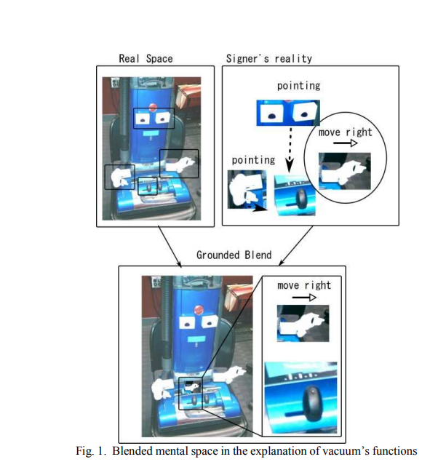

**C. Expressions achieved by gesture robot**

The gesture robot transforms into a communication entity equipped with robotic eye and arm-like components, presenting human-like representations of various objects. These representations offer nuanced expressions, enriching user interaction by providing enhanced cues, surpassing the guidance available in conventional printed manuals. This section delineates three distinct expressions achieved through our robot.

* **Pointing Gestures:** Pointing gestures, fundamental in human-human communication, also find utility in human-robot interactions. These gestures effectively indicate the precise location of each feature. The robot employs two pointing gestures: spot pointing and region pointing. Spot pointing involves directing users to specific spots on its "body," such as indicating the hose detachment point, utilizing the eyes and arms to guide the user (Fig. 2A). Region pointing, on the other hand, draws attention to broader regions, like the electrical cord area, where the eyes direct towards the region's center while the arm employs a waving gesture to indicate the area (Fig. 4B).
* **Moving Suggestions:** Moving suggestions elucidate how to manipulate features. After pointing gestures guide users to the target spot or region, the arms illustrate movements for users to mimic while maintaining focus on the target. For instance, upon recognizing the target, such as a power switch, indicated through pointing gestures, the robot's hand mimics the required gesture, demonstrating how to engage the switch and power the vacuum (Fig. 3).
* **Emotional Gestures:** Anthropomorphizing objects allows for emotional representation, enabling users to gauge the appliance's state. Emotional cues, portraying happiness or sadness, serve as indicators of training progress or potential issues with the appliance (Fig. 4). These representations foster user motivation and congeniality toward the appliance. While emotional representations may seem abstract, studies indicate users' comprehension of these emotions [9] [10]. Further research in human-robot interaction supports the hypothesis that emotional gestures evoke affable feelings and bolster motivation.

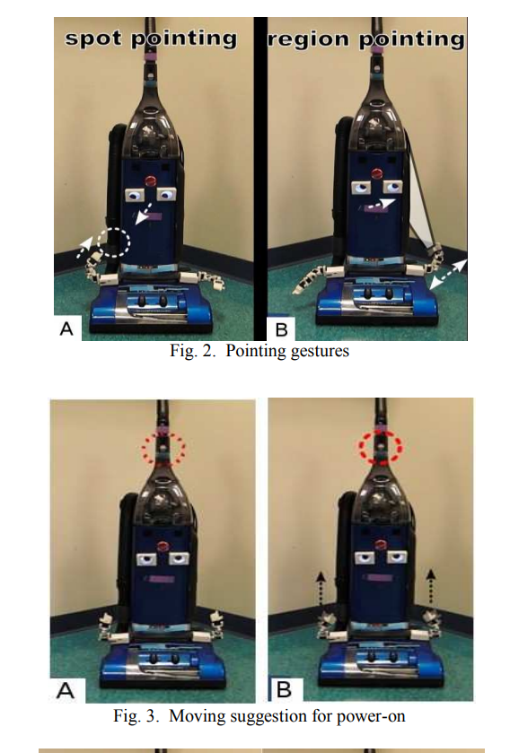

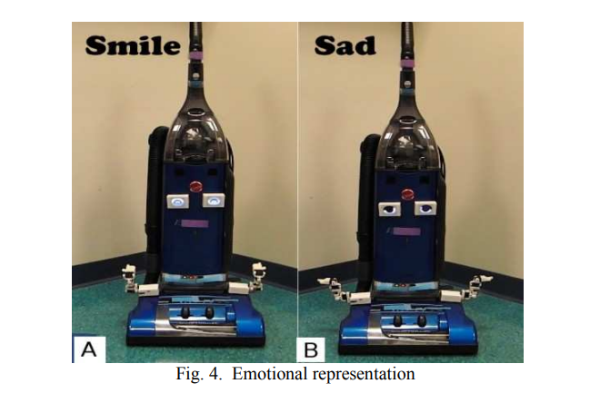

D. **Implementation of a gesture robot**

* **Hardware:**

In contrast to typical manipulation robots, our anthropomorphized objects don't engage in physical interactions with other objects. Their role primarily revolves around directing user attention and expressing emotions without intervening in the object's functionalities. This requirement necessitates lightweight and uncomplicated devices that can be easily affixed without disrupting operations. To meet these criteria, we engineered compact human-like robotic components attached using hook and loop fasteners (Fig. 5). These devices, being lightweight, are adaptable for attachment to various locations.

The eye-like device comprises an OLED panel featuring a pupil, iris, and eyebrows, enabling directional gaze simulation as if the device possesses visual perception. Meanwhile, the arm-like part comprises four servo motors, specifically i-Sobot motors . These motors execute precise pointing positions through inverse kinematics algorithms and perform diverse gestures, including emotional expressions. Concealing these parts with cloth prevents imparting a machine-like impression. Each component operates on its own battery, delivering over five hours of usage before requiring recharging. These devices establish Bluetooth connections with a control terminal and are affixed using Velcro tape.

* **Software:**

Initially, configuring the body involved strategically positioning anthropomorphic features on specific locations to emulate a robot's appearance, considering the device's absence of a predefined body shape. The system was designed to flexibly adapt its form, deviating from the conventional fixed-body robot structure (Fig. 6). Creating an abstract body image was accomplished using the Body Image Creator module, employing marker-detection facilitated by ARToolKit for computing part positions and pointing targets [14] (Fig. 7). Subsequently, integrating the appliance's manual into the system enabled the addition of pointing gestures, varied gestures, and emotional representations corresponding to feature locations. Sections from the original manufacturer's manual were selected to generate a training scenario. Upon implementing these methodologies, our anthropomorphized device robot functioned akin to a standard communication robot. As users approached the object, the robot commenced explanations of its features based on the predefined communication scenario. A synthesized voice relayed information by articulating text derived from the manual.

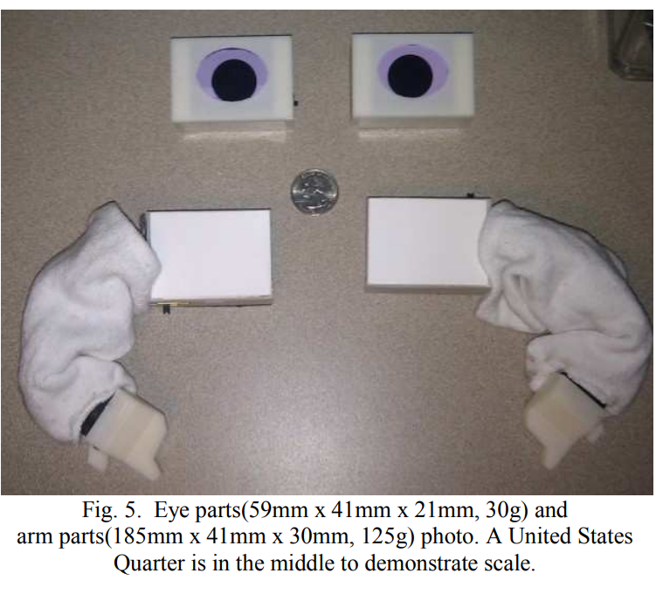

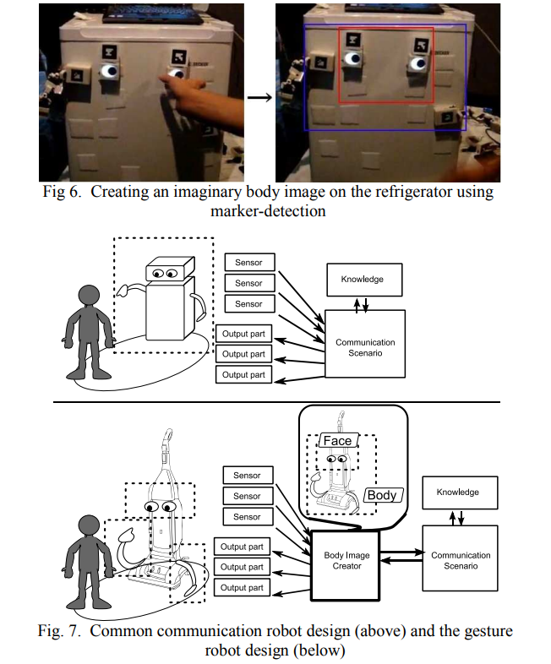

E. **Experiment**

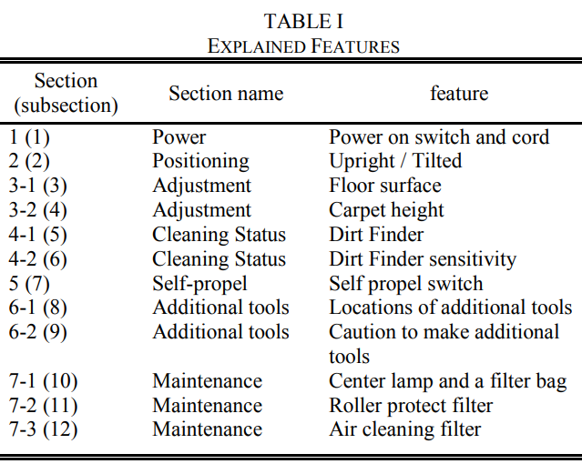

To assess the impact of gestures on voice interaction, a task simulating a household scenario was devised—learning the features of a new vacuum cleaner. Older adults were engaged in self-guided training sessions, comparing motivation and emotional states between those using a user's manual and those utilizing an anthropomorphized device.

* Training Method Development:

The selected household appliance, the Hoover Wind tunnel [15], was chosen for its multifaceted functionalities, featuring five switches, three lights, two doors, and six additional cleaning tools. Seven sections from the original manufacturer's manual were condensed into a simplified version comprising 12 parts elucidating the vacuum's features (Table 1). Two conditions were established: a control condition utilizing auditory instructions derived from the manual and an experimental condition integrating robotic gestures highlighted in Section 3. The experimental scenario incorporated emotions to emphasize crucial training points. To enhance comprehension, a recorded female voice was utilized, modified to sound robotic and high-pitched.

* Participant Details:

Data was gathered from 30 English-speaking American participants aged 60 to 80 years without neurological or cognitive impairments. Divided into two groups—15 participants (6 males) in the experimental (gestured) group and 15 (6 males) in the voice-only (control) group—each cohort possessed operational familiarity with household appliances.

* Experimental Setup:

The experimental room (Fig. 8) arranged a 1.6m distance between the vacuum and seated participants positioned on rolling chairs. They were encouraged to move freely during the training.

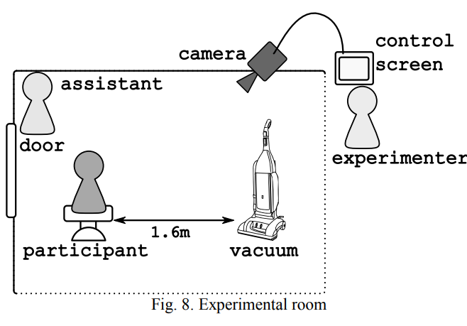

* Participant Instructions:

After initial formalities, participants received instructions for the self-guided training. They were oriented to imagine owning and learning to operate the newly acquired vacuum cleaner. An instruction sheet comprising nine commands facilitated the training process. Interaction with the vacuum entailed posing seven questions corresponding to sections delineated in Table 1. The experimental group's training involved recorded voice explanations paired with robotic eyes and arms gesturing towards vacuum areas. In contrast, the control group relied solely on recorded voice instructions without robotic gestures. All utterances and gestures during the 30-minute session adhered to a pre-set script.

* Evaluation and Methodology:

Post-training, participants identified vacuum features through photos and rated their emotional state using a 4-point Likert scale pre and post-experimentation (Table 2). Emotional scores gauged motivation, indicating sustained motivation if scores remained stable or increased post-training. A decrease signaled reduced motivation. It was anticipated that emotional scores would be higher in the experimental group, indicating enhanced motivation compared to the control.

Additionally, participants' capability to correctly label vacuum features post-training was assessed. The hypothesis posited a higher accuracy rate in the experimental group due to the inclusion of gestures aiding comprehension.

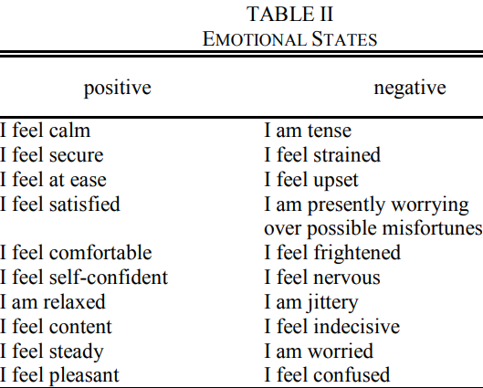

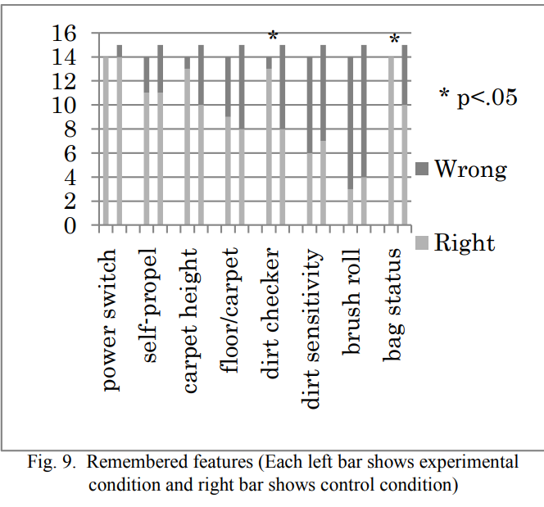

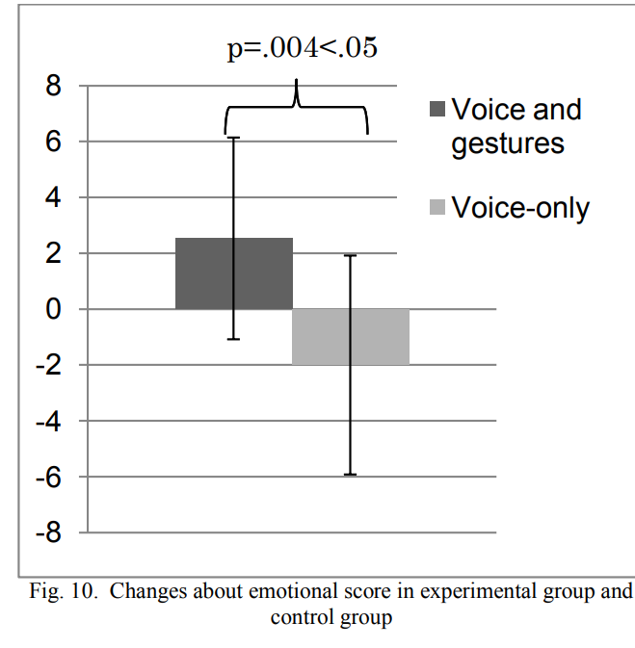

F. **Result**

Fourteen participants from the experimental group and fifteen from the control group provided the functions of various vacuum features they had learned. An analysis using Fisher’s exact test revealed that two features were notably better remembered in the experimental condition (Fig. 9). Specifically, the dirt checker light and bag status light were recalled by a higher number of participants in the experimental group compared to the control group.

The comparison of emotional scores pre and post-experimentation showcased a noticeable difference between the groups (Fig. 10). Participants in the voice and gesture method exhibited an average increase in their emotional status by 2.53, whereas those in the voice-only method showed an average decrease of -2. The statistical analysis (t-test) indicated a significant difference (p=.004<.05) between these emotional score variances.

The observed disparity in remembered features between the groups does not stem from a lack of information provided in the control condition. Instead, it underscores the additional advantage conferred by gestural movements. Both groups received precise auditory instructions regarding feature locations, yet the gesture-based approach proved more effective in aiding older adults to retain spatial information. The findings strongly suggest that the gestures accompanying the anthropomorphized condition significantly assist older adults in mentally manipulating these spatial representations. Figure 11 illustrates how a participant utilized gesture cues to enhance her mental imagery by emulating the robot's gesture. Moreover, the disparity in emotional scores suggests that our gesture robot engenders a more enjoyable experience for older individuals. This inclination towards a more positive emotional response aligns with the perceived benefits of the gesture-based interaction method.

**Challenges in patient care sytems**

In the realm of patient care systems, several challenges obstruct the seamless delivery of optimal healthcare services. These challenges encompass multifaceted factors that significantly influence the efficacy and accessibility of care, the financial burden on patients, the quality of services provided, and overall patient satisfaction. Understanding these obstacles is crucial in crafting solutions that bolster healthcare outcomes.

Accessibility to healthcare services remains a pervasive challenge, particularly for marginalized or remote communities. Geographic barriers, lack of transportation, and limited healthcare facilities in rural areas impede individuals' access to timely medical attention. Additionally, socioeconomic factors such as income disparities and inadequate health insurance coverage exacerbate accessibility issues, leaving many individuals without essential healthcare.

Affordability of healthcare services stands as another substantial hurdle. Rising healthcare costs, coupled with the absence of comprehensive insurance coverage, impose significant financial strain on patients. High out-of-pocket expenses, co-payments, and deductibles often deter individuals from seeking necessary medical care, leading to delayed treatments or avoidance of essential services.

The quality of care offered within patient care systems is a critical concern. Issues such as medical errors, disparities in treatment, and variations in healthcare standards across different facilities can compromise the quality and consistency of care. Ensuring standardized protocols, enhancing healthcare provider training, and implementing stringent quality control measures are imperative to mitigate these challenges and maintain high-quality care.

Moreover, patient satisfaction is an essential aspect that directly correlates with the effectiveness of healthcare systems. Communication gaps between healthcare providers and patients, long wait times, inadequate information dissemination, and a lack of personalized care contribute to diminished patient satisfaction levels. Building effective communication channels, promoting patient-centered care models, and improving overall healthcare experiences are pivotal in enhancing patient satisfaction.

Addressing these challenges demands a multifaceted approach involving policy reforms, investment in healthcare infrastructure, enhanced education and training for healthcare professionals, and the integration of technology to streamline services and improve access. Collaborative efforts among stakeholders, including governments, healthcare institutions, insurers, and communities, are necessary to overcome these challenges and cultivate patient care systems that prioritize accessibility, affordability, quality, and patient satisfaction for all.

**Enhancement strategies**

Enhancing patient care systems involves a concerted effort across multiple fronts, integrating innovative strategies, technological advancements, and policy reforms to elevate the quality, accessibility, and effectiveness of healthcare services.

1. Proposed Enhancement Strategies:

a. Integration of Telemedicine: Telemedicine has emerged as a transformative tool, enabling remote consultations, monitoring, and diagnosis. Its implementation extends healthcare services to remote areas, facilitates timely interventions, and minimizes geographical barriers. Enhanced access to specialists and real-time consultations improve patient outcomes, particularly for individuals with limited mobility or residing in underserved regions.

b. Harnessing Artificial Intelligence (AI): AI applications revolutionize patient care by streamlining diagnostics, predicting disease patterns, and personalizing treatment plans. Machine learning algorithms analyze vast datasets to identify trends, assist in early disease detection, and optimize treatment protocols. AI-powered tools enhance efficiency in medical imaging, automate administrative tasks, and support clinical decision-making, thereby reducing errors and enhancing patient safety.

c. Leveraging Internet of Things (IoT): IoT-enabled devices offer remote monitoring and real-time data collection, fostering continuous patient engagement and personalized care. Wearable sensors, smart devices, and connected health platforms allow for seamless tracking of vital signs, medication adherence, and chronic condition management. This proactive approach enables timely interventions, preventive care, and better disease management.

2. Technological Advancements and Their Role:

Technological innovations like telemedicine, AI, and IoT revolutionize healthcare delivery. Telemedicine's role expands beyond remote consultations, encompassing virtual care, telemonitoring, and telepsychiatry. AI augments clinical decision-making through predictive analytics, personalized treatment plans, and precision medicine. IoT devices, interconnected through healthcare ecosystems, enable data-driven insights for proactive interventions, remote patient monitoring, and patient empowerment.

3. Impact of Policy Reforms on Patient Care Quality:

Policy reforms play a pivotal role in shaping healthcare systems. Reforms focused on expanding telehealth coverage, reimbursement policies for remote care, and regulatory frameworks for AI and IoT implementation foster innovation adoption. Embracing interoperability standards ensures seamless data exchange among healthcare providers, enhancing care coordination and patient safety. Policies promoting research funding, data privacy, and ethical AI development safeguard patient rights and encourage responsible innovation.

**Conclusion**

In conclusion, the landscape of patient care systems is evolving rapidly, presenting both challenges and unprecedented opportunities for improvement. Addressing obstacles in accessibility, affordability, quality, and patient satisfaction requires a multifaceted approach integrating innovative strategies, technological advancements, and policy reforms. The proposed enhancement strategies encompass the integration of telemedicine, harnessing artificial intelligence (AI), and leveraging the Internet of Things (IoT). These transformative tools have shown immense potential in extending healthcare access, personalizing treatments, and revolutionizing care delivery. Technological advancements, notably telemedicine, AI, and IoT, play pivotal roles in reshaping healthcare paradigms. They transcend geographical barriers, enhance diagnostic accuracy, and empower patients through continuous monitoring and personalized interventions. Policy reforms are integral to fostering an environment conducive to innovation adoption and ensuring ethical, equitable, and patient-centered care. Reforms focusing on telehealth expansion, interoperability standards, and ethical AI development are paramount for navigating the evolving healthcare landscape.

Embracing these strategies and reforms necessitates collaboration among stakeholders, investment in infrastructure, and a commitment to ethical, responsible innovation. The integration of these approaches holds the promise of creating patient-centric, efficient, and high-quality healthcare systems that cater to the diverse needs of individuals worldwide. As we navigate this transformative era in healthcare, it is imperative to remain vigilant in addressing ethical concerns, ensuring equitable access, and prioritizing patient well-being. Through collective efforts and a commitment to continuous improvement, we can forge patient care systems that transcend boundaries, optimize outcomes, and uphold the fundamental principle of providing quality care for all.

**References:**

**[**1] Burdick, D. C., Kwon, S. (2004). "Geotechnology: Research And Practice In Technology And Aging." Springer.

[2] Salthouse, T. A. (Ed.). (1991). "Theoretical perspectives on cognitive aging." Hillsdale, NJ: Lawrence Erlbaum Associates.

[3] Mead, S. E., Rogers, W. A. (2000). "Developing technology to support the functional independence of older adults." Ageing International, 27, 24-41.

[4] Falconer, G. (1985). "Mental Spaces." Cambridge, MA: MIT Press.

[5] Liddell, S. K. (1996). "Spatial representations in discourse: comparing spoken and signed language." Lingua, 98, 145-167.

[6] Hirotaka Osawa, Ren Ohmura, Michika Imai. (2009). "Using Attachable Humanoid Parts for Realizing Imaginary Intention and Body Image." International Journal of Social Robotics, 1(1), 109-123.

[7] McNeill, D. (1992). "Hand and Mind." University of Chicago Press.

[8] Okuno, Y., Kanda, T., Imai, M., Ishiguro, H., Hagita, N. (2009). "Providing route directions: design of robot's utterance, gesture, and timing." Proceedings of the 4th ACM/IEEE international conference on Human-robot interaction, pp. 53-60.

[9] Bartneck, C. (2001). "How Convincing is Mr. Data’s Smile: Affective Expressions of Machines." User Modeling and User-Adopted Interaction, 11, 279-295.